CHAPTER 2

LITERATURE REVIEW

2.1. INTRODUCTION

Emergency Vehicle Preemption has been an important consideration because of its potential to save lives. However, emergency vehicle preemption adversely affects overall traffic flow. Giving priority to emergency responders has been a tradition even before current ITS preemption technologies came in to existence. Vehicles moved out of the way to provide space to the emergency vehicle. Safety concerns and increasing traffic volumes, combined with improved technologies, encouraged the implementation of ITS strategies to provide a special green interval to the emergency vehicle while ensuring red intervals to conflicting approaches.

A review of the state of the practice on vehicle preemption is provided. Its usefulness, benefits and consequences are highlighted followed by a discussion of the different techniques currently in use. Finally, a summary of research into advanced applications is provided.

2.2. CURRENT STATE OF PRACTICE

The history of preemption started in 1929 when the American Engineering Council publication described the need for supplemental arrangements for emergency vehicle operation in a coordinated system. Technology for incorporating preemption in signal systems started developing in the 1960s. This resulted in the first of its kind preemption system devised by 3M in the early 1970s. These early systems had a detector attached to the signal heads to detect pulses of strobe lights from emergency vehicles to transition the signal phase to a special mode as shown in figure 1. St. Paul, Minnesota was one of the first to adopt EVP in its signal system where almost 100 percent of the traffic controllers had preemption control.

In 1979, 3M built a new system which could prioritize preemption requests. This marked the beginning of Transit Signal Priority with the system allowing two priorities, a higher for emergency vehicles and a lower for transit vehicles. The brand name Opticom was given to these preemption products which included a separate emitter unit required for emergency vehicles and transit vehicles. Soon, infrared emitters and detectors replaced strobes because of the public use of strobe lights to fool traffic signals. In 1992, 3M added encryption codes to its infrared transmitters to avoid false preemption calls made by hackers.

Recently, technological advancements, such as use of GPS to calculate the latitude, longitude, speed and heading of emergency vehicles, came into common use. Today, the 3M Opticom Preemption System is the most commonly used in the United States. Ninety-eight metropolitan areas have installed it in more than 30,000 intersections which represents one-fifth of all signalized intersections in the United States. Cities like Bellingham (WA), Boise City (ID) and Syracuse (NY) have recently implemented preemption systems in more than 90% of their signalized intersections.

2.3. BENEFITS AND CONSEQUENCES

The rapid growth in populated areas has resulted in increased congestion which has resulted in multiple impacts to the emergency operations community. It has increased the risk of emergency vehicle crashes as well as the response time of emergency teams. Emergency Vehicle Preemption has helped to mitigate these impacts but often at the cost of higher travel time for cross-street traffic and, in some cases, traffic gridlock.

2.3.1. BENEFITS

Emergency Vehicle Preemption has many advantages. These include faster response by the emergency team, improved safety for emergency vehicles as well as other vehicles, cost savings to the public because of reduced property loss which is enabled by quicker emergency response and cost savings to the authorities because of a larger service area for each emergency dispatch station.

a) Faster Response:

Studies done by FHWA showed that providing green to emergency vehicles improves response times by reducing driver confusion and conflicts and increasing the average speed maintained by an emergency vehicle. In an analysis of the implementation of emergency vehicle preemption in Fairfax County, Virginia, it was shown that, on average, 30 to 45 seconds are saved per intersection for emergency vehicle movement along the US 1 corridor. Studies done by the City of Denver Department of Safety in 1978, also verified an improvement in the level of service. This study, which was done over a 90-day period in an area with three fire stations and 75 signalized intersections, showed a 14 to 25 percentage reduction in response time. An emergency vehicle movement involving three to six signalized intersections showed average savings of 70 seconds.

Such savings can be of critical importance in case of an emergency. The American Heart Association stated that the survival chances for a cardiac arrest patient are reduced by 7 to 10 percentage for every minute lost until defibrillation. A small fire doubles every 17 seconds and can reach flashover in 7 minutes. Hence, fire and rescue operations have set the operational standard response time to be less than 7 minutes. Emergency Vehicle Preemption can help achieve this goal.

b) Improved Safety:

The Fatality Analysis and Reporting System (FARS), a web-based encyclopedia of crash fatality statistics in the United States maintained by the National Highway Traffic Safety Administration, shows that approximately one-fourth of the crashes involving emergency vehicles in the last ten years are intersection crashes. Such emergency vehicle crashes have larger impacts than ordinary vehicle crashes. On one hand, it delays emergency service to 9-1-1 calls. On the other hand, it results in increased injury and possible death to emergency care personnel. It also forms a financial liability for emergency care units. Studies have shown that implementation of Emergency Vehicle Preemption can help in reducing intersection related crashes of emergency vehicles. In the city of Plano, Texas, the intersection crash rate of emergency vehicles was reduced from 2.3 crashes per year to less than one in five years after the implementation of Emergency Vehicle Preemption. In St. Paul, Minnesota, where the preemption systems were deployed as early as 1976, emergency vehicle crashes were reduced by 50% despite the considerable increase in population. St. Paul showed a decline of emergency vehicle crashes from 8 to an average of 3.3 post-installation.

c) Savings to the Public:

The implementation of Emergency Vehicle Preemption can save the public money. A faster response can save lives which are priceless. Property losses are also minimized. Apart from the savings yielded from lower property loss and fatalities, it also enhances the insurance industry rating for the community’s fire suppression service; thereby reducing insurance costs. The Town of Blacksburg, Virginia, has reported an improvement in its Insurance Service Organization (ISO) class due to faster responses after preemption installations.

d) Savings to the Authorities:

Emergency Vehicle Preemption has helped to increase the service area of each fire and rescue station because of its potential higher level of service. The city of Plano, Texas was able to serve an average of 7.5 square miles per fire station after the installation of preemption systems whereas the target service area per fire station without preemption was 5.6 square miles. This has helped them save $9 million in construction costs and $7.5 million in annual operating costs.

2.3.2. CONSEQUENCES

Although the implementation of Emergency Vehicle Preemption can help reduce the travel time of emergency vehicles, it can affect overall traffic negatively. Studies were con-ducted in New York City to evaluate the impact and benefits of Emergency Vehicle Preemption. This study showed an improved emergency vehicle operation at all the six locations, but also showed a disruption in the coordination of the signal systems. Recovery required not less than four cycle lengths. Also, it showed an average increase in traffic delay of 4 to 58 percent.

Also an increase in overall travel time to one to two percent was observed. The study also stated that the effect depended on upstream preemption distance, corridor volumes and baseline timing plan. Coordination of signals was not considered in this study. A year later, in 2000, preemption was tested in a closely spaced arterial with various preemption paths and transition algorithm. As stated in the previous research, a single preemption had negligible effects on the overall traffic, whereas, multiple preemptions caused severe delays to the overall traffic.

2.4. CURRENT TECHNIQUES

Several advancements took place in preemptive techniques over the last four decades. These advancements mainly occurred in the technology of transmission and reception of calls. From detection of strobe lights for placing calls to the latest GPS enabled Automatic Vehicle Location system, almost all the advancements were concentrated on placing preemptive calls. Another concentration of research has focused on the transition of preemption or how to transition into and out of the preemptive operation. Since normal signal timing and logic is different from the signal timing and logic used during preemption, a transition is required between the two timing plans. Guidelines for this transition are given in the Manual on Uniform Traffic Control Devices and include:

Transition into Preemptive Phase:

* Yellow and All-red intervals should be served before transitioning to preemptive phase.
* Pedestrian wall interval or clearance interval may be shortened according to the priority received.
* Returning to a previously served steady green interval is permitted following a steady yellow interval in the same approach and omitting all-red interval.

Transition out of Preemptive Phase:

* Yellow and All-red intervals must not be shortened.
* Returning from a yellow interval to green is not permitted during transitioning out with-out an all-red interval.

Figure 2.1 shows the logical operation of a controller during normal emergency vehicle preemption from the moment that the preemption call is received until the operation switches back to normal logic.

Studies also showed that the transition strategy has impacts on the safety and efficiency of the general traffic at an intersection and hence the right strategy must be used to exit preemption control. This occurs because transitioning involves reallocation of green time. Some of the transition strategies in use are summarized in Table 2.

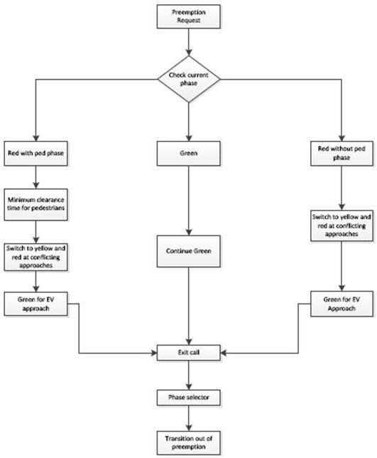

Figure 2.1: The logical operation of a controller during normal emergency vehicle

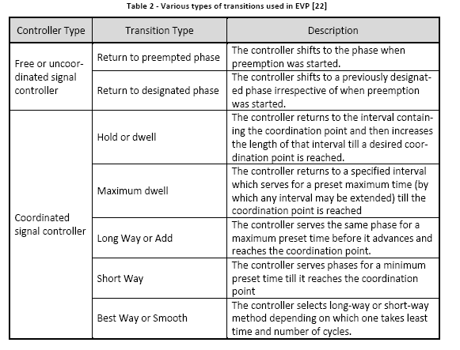

2.5. ADVANCEMENTS

ITS is growing rapidly and with the latest generation of GPS equipped systems which can pinpoint the emergency vehicle’s location and speed, Emergency Vehicle Preemption is receiving greater acceptance among communities. The system in one part of the world helps emergency vehicles to reach incident locations in a shorter time, whereas in traffic-strangled Middle Eastern cities like Dubai, it is being implemented to allow diplomats and sheikhs to quickly move through traffic. Current EVP systems can work with vehicle circuitry to clear side-street traffic if the turn indicator is operated. It can also cancel preemption requests when the vehicle switches to the parking gear if the incident location is near an intersection. In many places, traffic lights are equipped with floodlights which can show the path of emergency vehicle movement and, thereby, let commuters know that it is in a preemptive phase.

In spite of these advancements, limited research has been done in optimizing emergency vehicle movement along a congested corridor with preemption. Literature shows that most of the preemption systems are still working on an intersection-to-intersection basis. Al-though there are preemption systems which can invoke preemption at the next intersection, they still require local detection of the emergency vehicle . In the research done, a dynamic sequential preemption method showed a 10-16 percent reduction in travel time of emergency vehicles, even with long and complicated routes. It dealt with a sequential preemption approach in which signals are preempted automatically in a selected route for emergency vehicle movement.

In this research, the sequential preemption will be aided by offsets similar to a signal progression pattern. These offsets will be set either by real-time congestion levels or pre-set time-of-day congestion levels. Such a system should be effective and inexpensive to implement.